CDR Architecture Diagram Walkthrough.

Wednesday, June 23, 2021

10:35 AM

Attendees: Seun Mafi, Prashanth Yelukati, Aerozona Obiadazie, David Dessommes, Jason Nazare, John Vrab, Maria Braun, Matthew Colville, Mike Fitz, Moriah Striegel, Olivia Lawson, Saicharan Sirangi, Sanjit Das, Saurabh Dilip Saxena, Tushar Mohapatra, Yogesh Shinde

Agenda:

Machine generated alternative text:
Dot. 
01 
CDR Foundational Logical sketch Initial Draft 
Int«fx./ 
EPIC 
PIC. Minu1eClin.c,'Lab 
- WON in Progress 
ata 
Files. CCD ML. 
JSC'.O 
(subject to Change) 
CVS 
Health 
API 
(FHIR st-MN) 
data) 
FHIR APIs 
sana&neaunte 
Use Cm 
Audit 
OAuth2,o 
Consent 
(cline 
Immunitat'ons 
Lob 
Legend 
igilial 
CKD App 
Health 
patient,' Member 
Car e Sloff 
ital g.atth 
isk 
D ata L 

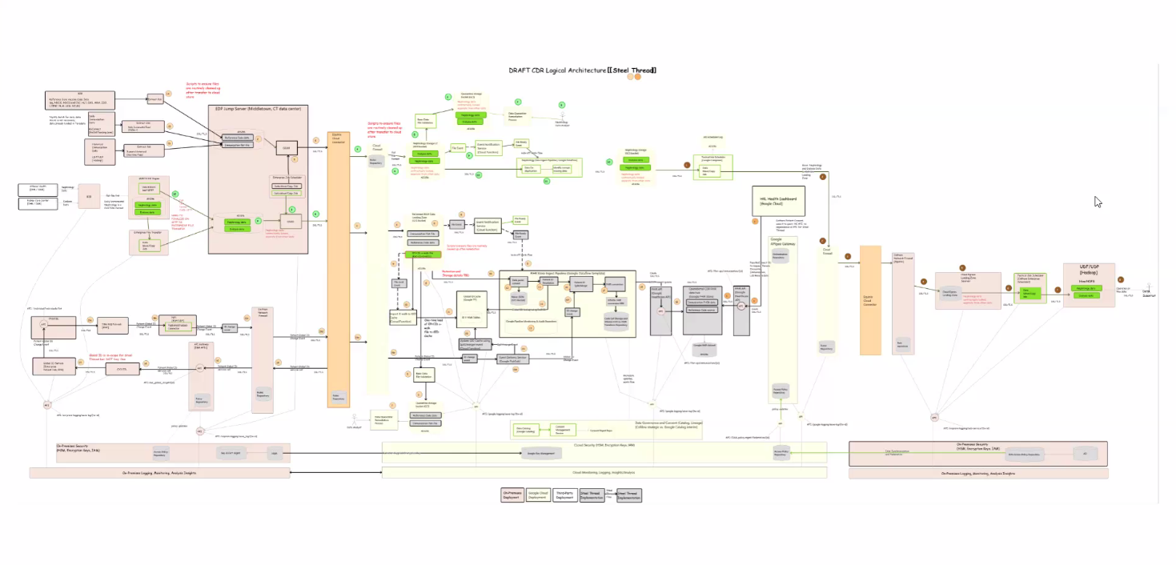Data whether at rest or in motion is encrypted.

Machine generated alternative text:
IG-cs 
G) 
TBD 
FIHR Store Ingest Pipeline [Google Dataflow template] 
operational CDR FHIR 
data 
FHIR 
Data and Consent (Catahg. LQage 
API 
of EPH ID 
file 
GIO 
e Subl 

Google Spanner Tool

Olivia will share all the documents (Architecture Diagram) with the team on Auditboard.